Daz’s Tasty Treats

Birthday Cake Bars
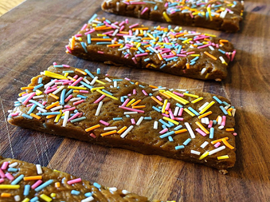
1 cup of cashew nut butter
3 tbsp runny honey
2 tbsp almond butter
1/3 cup hemp protein powder
1 tbsp almond milk
1.5 tsp vanilla extract
2-3 tbsp of sprinkles

Method
Blend together the almond flour, coconut oil, maple syrup, coconut milk, vanilla extract and salt together.

Place in a bowl and mix in 1/2 cup of the chocolate chips, then place in the fridge for 1 hour.

Roll into balls and dip into the remaining melted chocolate chips before placing back in the fridge to set.
Daz’s Tasty Treats

Peanut Butter Freezer Fudge

1 1/2 cups of smooth peanut butter
1/2 cup dates
1/4 cup coconut oil
Pinch of salt
2 tbsp of dark chocolate drops
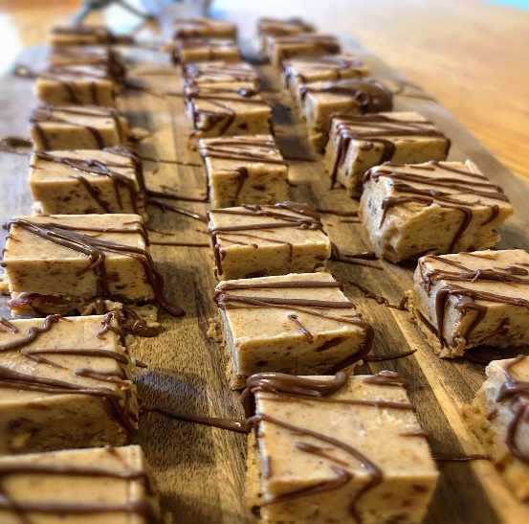
Method
​
1 put the peanut butter, dates, coconut oil and salt into a food processor and blend until smooth.
2 line a container with parchment paper, add the fudge mixture and spread evenly.
3 Seal the container and place in the freezer for 3 hours or until the fudge has hardened.
4 Drizzle the fudge with melted chocolate, pop back in freezer for the chocolate to set and then cut the fudge into squares.
5 Store the fudge and enjoy from the freezer.
​
​Daz’s Tasty Treats

Homemade Snickers Bar
Method

1 Line a loaf tin with parchment paper
2 Mix together the bottom layer ingredients until dough like and then spread evenly across the loaf tin.
3 In a small pan bring the peanut butter, coconut milk, maple syrup and vanilla extract to a mild boil. Turn to a low head and let it simmer, stirring occasionally. When the mix starts to go a golden brown and begins to thicken pour evenly over the bottom layer.
4 Sprinkle peanuts over the middle layer and push in with a spoon.
5 Melt the chocolate chips and pour over the middle layer.
6 Pop in the fridge for a couple of hours.
7 Cut into bars and enjoy
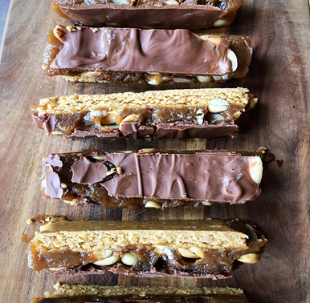

•Bottom layer

1 cup of oat flour

1/2 cup of smooth peanut butter

2 tbsp maple syrup

•Middle layer

1/2 cup of smooth peanut butter

1/2 cup of coconut milk

1 tsp of vanilla extract

1/4 cup maple syrup

1/3 cup of peanuts

•Top layer

1/2 cup of chocolate chips

​Daz’s Tasty Treats

Lemon & Mango Buzz Balls

Ingredients

115g dried mango
50g desiccated coconut
55g Brazil nuts
Zest of 1 lemon
Juice of half a lemon
1 tsp chia seeds

Method

Put the mango into a bowl and cover with hot water. Leave it to soak for 20 minutes, drain well and pat dry.
Toast the coconut in a dry frying pan until lightly golden.
Blitz the Brazil nuts in a food processor until finely chopped, add the toasted coconut, mango, lemon zest, lemon juice and chia seeds. Blend into a thick paste.
With damp hands shape the mix into 12 balls, then sprinkle with chia seeds. Pop in the fridge to firm up.

Keep them in the fridge for up to a week to enjoy as you please.
​

Daz’s Tasty Treats

Quick Red Berry Smoothie

Ingredients

2 bananas
Handful of frozen red berries
1 tbsp crunchy peanut butter
Coconut water

Method

Break up the bananas into a blender/smoothie cup.

Add the crunchy peanut butter, the red berries before covering with coconut water and then wiz together until smooth.

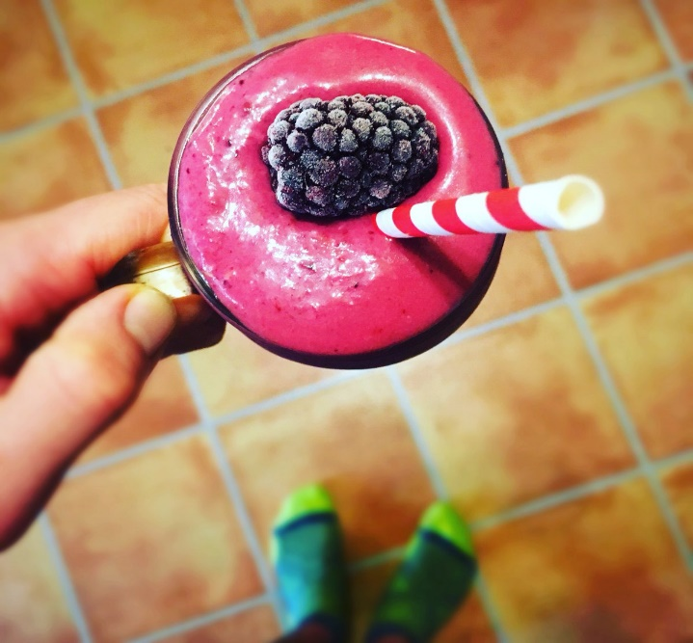

Daz’s Tasty Treats

Honey & Peanut Butter Flapjacks

Ingredients

50g smooth peanut butter
160g runny honey
100g butter
170g oats

Method

Line a small baking tin with parchment paper.

Place the honey and butter into a pan and warm on a low heat until melted.

Add the oats and peanut butter and mix up until it’s all nicely combined together.

Pour the gooey mix into the baking tin and spread around evenly.

Place in the oven at gas mark 4 and bake for 20 minutes or until golden brown.

Leave to cool before cutting into squares and enjoying.

Here’s a 60 second video of how I made them https://youtu.be/iJ-74FU6-uc

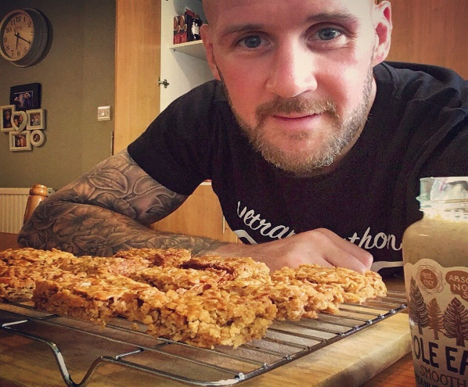

Daz’s Tasty Treats

Peanut Butter Truffles

Ingredients
2 cups of crunchy peanut butter
2 ripe bananas
2 tbsp flaxseed
2 tbsp cocoa powder

Method
Mix the peanut butter, bananas and flaxseed together with a fork in a large bowl.
Mold the peanut butter mixture into balls and roll in the cocoa powder.
Place the balls into a container lined with parchment paper and pop into the freezer for a few hours.
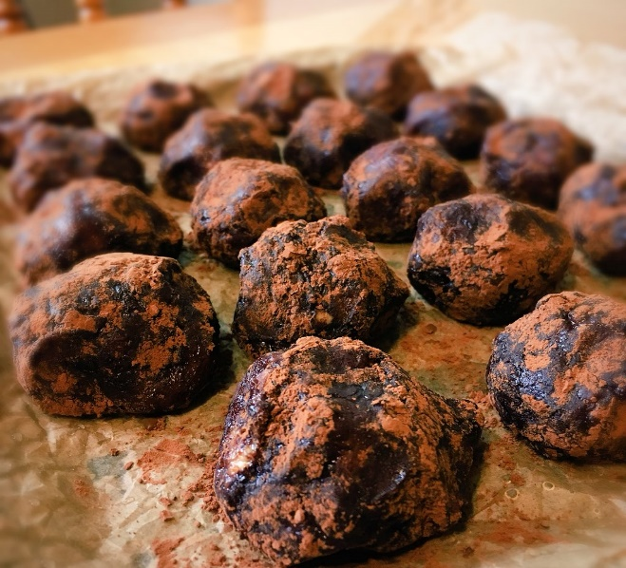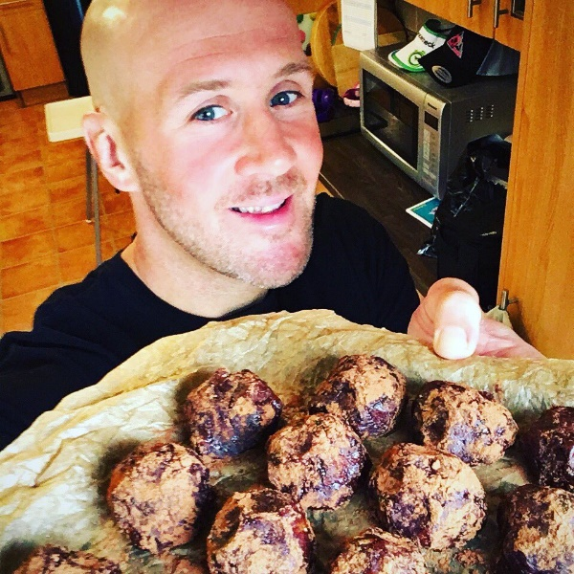

Daz’s Tasty Treats

Peanut Butter and Chia Seed Energy Bites

Ingredients

60g rolled oats
150g crunchy peanut butter
1 tbsp melted coconut oil
15g chia seeds
1/2 tbsp runny honey

Method

Put all the ingredients into a bowl and mix together until it has all combined.

Then form bits size balls with the mixture and place onto a parchment lined plate.

Wetting your hands will help when making the balls otherwise they tend to stick to your fingers.

Place the energy bites into the fridge and they are good to eat in 30 minutes.

Enjoy!

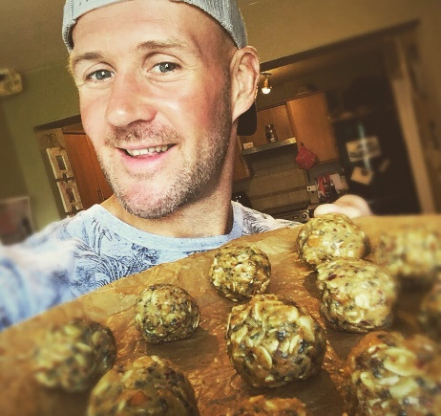

Daz’s Tasty Treats

Overnight Oats

Ingredients
​
50g oats
150g natural yogurt
25g raisins
25g mixed nuts
25g mixed seeds
100g frozen berries
1 sliced banana

Method

This is super simple and being able to prepare a tasty breakfast the night before saves so much time in the morning. I love to have these overnight oats waiting in the fridge for me when I come in from a morning run.

Throw all the ingredients into a bowl, mix together, place in the fridge and enjoy in the morning.

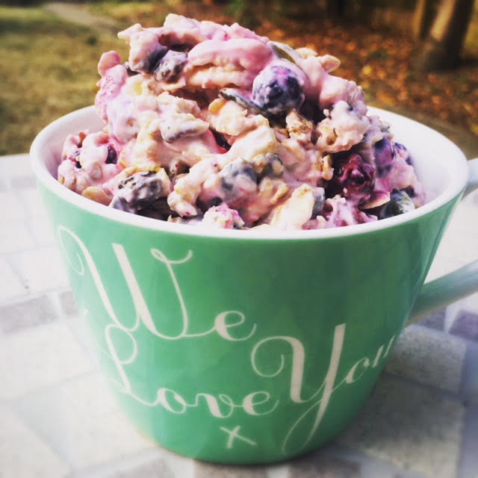
Daz’s Tasty Treats

Mango Fro-Yo

Ingredients
​
200g frozen mango chunks
5 heaped tbsp coconut yogurt
1 lime zested and juiced

Method

Put the mango, yogurt and lime juice into a blender and whizz until creamy and smooth. Sprinkle some lime zest and serve straight away.
​
This is so refreshing and great as pudding or just and afternoon treat to cool you down in the summer.

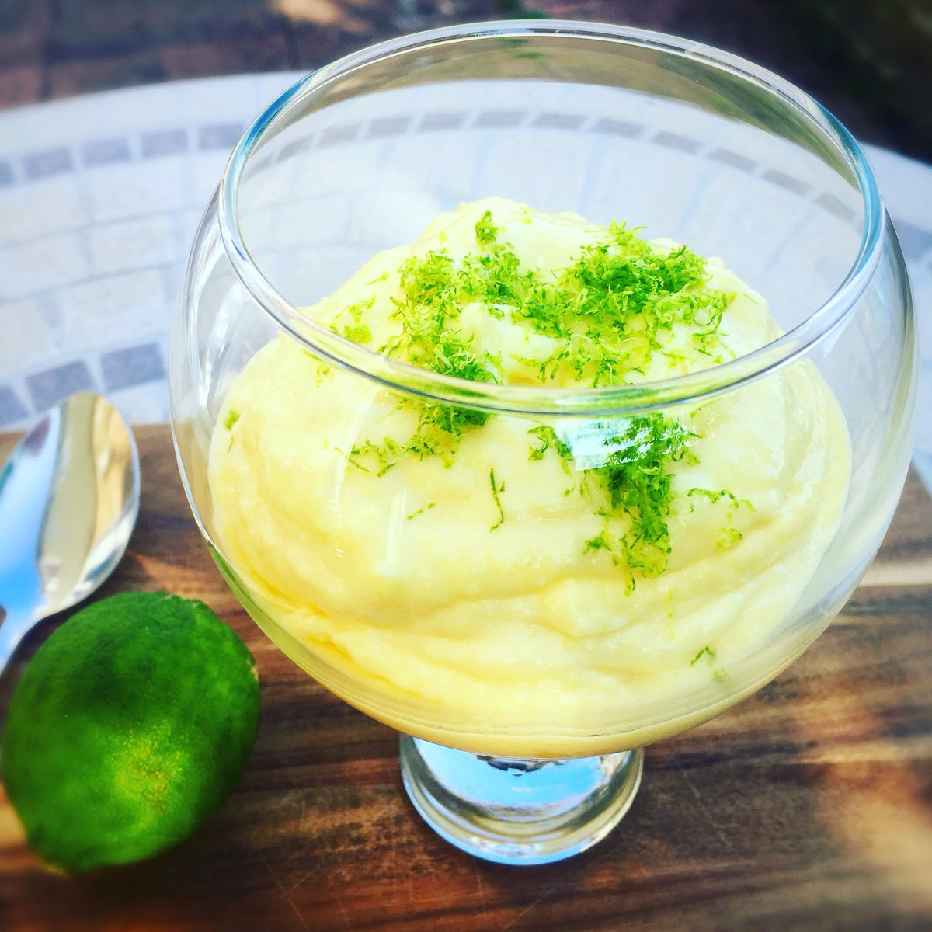

Daz’s Tasty Treats
Banana Loaf 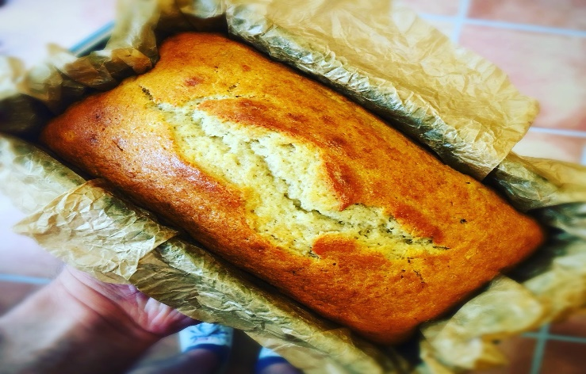

Ingredients

100g soft butter
175g caster sugar
2 eggs
2 ripe mashed bananas
225g self-raising flour
1 tsp baking powder
2 tbsp milk

Method

Put all the ingredients into a mixing bowl and beat until well blended.

Spoon the mixture into a lightly greased loaf tin which is lined with baking parchment and place into the oven for 1 hour at Gas Mark 4/180*C until it is golden brown.

Leave to cool for a few minutes before turning out the cake and placing on a wire rack to cool completely.

Daz’s Tasty Treats
Fruit & Energy Nut Balls 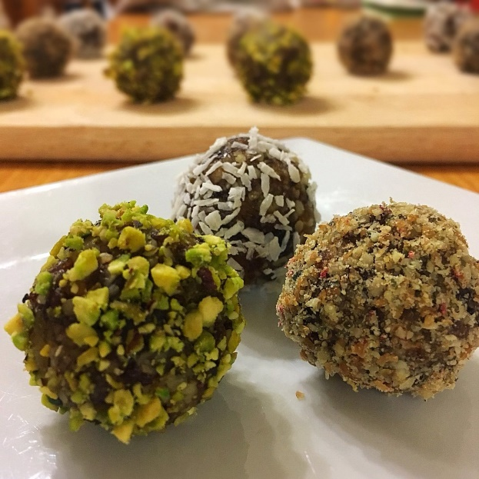

Ingredients

125g raisins
125g walnuts
75g dates
75g dried apricots

For Coating

Crushed pistachio nuts, desiccated coconut, milled mixed seeds and raspberries.

Method

Put all the ingredients into a food processor and whizz until combined. Divide the mixture and roll into balls with your hands. Gently roll each of the balls into the coatings. Put the balls in the fridge for 1 hour to firm up before eating.
​
Leave to cool for a few minutes before turning out the cake and placing on a wire rack to cool completely.

Daz’s Tasty Treats

Superfood Granola Balls

Ingredients

100g blueberries
50g runny honey
50g coconut oil
100g rolled oats
25g pumpkin seeds
25g sunflower seeds
25g chia seeds
50g flaked almonds
25g ground almonds
25g raisins
25g goji berries

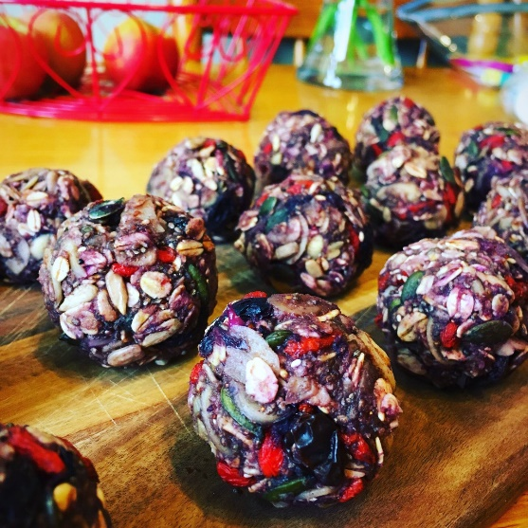
Method

Put the blueberries in a pan with 1 tablespoon of water. Bring to the boil and simmer until the blueberries are really soft and squishy. Add the honey and coconut oil and heat through until combined.

Combine all the other ingredients in a big bowl. Add the blueberry mixture to the dry mixture and stir until well combined. The mixture with be sticky. Divide up into 16 portions and roll into balls. Put them in the fridge for 1 hour before eating.

